Technical Report
Property Listings: Data Cleaning, Exploratory Analysis, Feature Engineering, and Hypothesis Testing
Dataset: raw_data.csv → clean_data.csv | 300 records, 8 attributes
Prepared by: Rishabh | Pipeline: 1_data_cleaning.ipynb → 2_eda.ipynb → 3_analysis.ipynb

Table of Contents
1. Overview & Objectives 3
2. Methodology 3
3. Data Collection & Preparation 4
4. Exploratory Data Analysis — Univariate 5
5. Exploratory Data Analysis — Bivariate 6
6. Feature Engineering 7
7. Statistical Analysis — Hypothesis Testing 8
8. Key Findings 9
9. Limitations 9
10. Recommendations & Next Steps 9
11. Conclusion 10
Appendix A — Glossary of Statistical Terms 10
Appendix B — Source Files 10

1. Overview & Objectives
This report documents the end-to-end analysis of a property listings dataset containing 300 records across 8 attributes: Property_ID, Area, Bedrooms, Bathrooms, Age, Location, Property_Type, and Price. The work spans four stages: data cleaning and preparation, exploratory data analysis (univariate and bivariate), feature engineering, and formal statistical hypothesis testing.
Primary objective: identify which property attributes are meaningfully associated with sale Price, quantify the strength of those relationships, and validate them statistically rather than relying on visual inspection alone.
Secondary objective: produce a clean, documented, reproducible dataset (clean_data.csv) and analysis pipeline suitable as a foundation for future predictive modeling.

2. Methodology
Analysis was conducted in Python using pandas for data manipulation, matplotlib/seaborn for visualization, and scipy.stats for hypothesis testing. Work was organized as three sequential Jupyter notebooks, each handling one stage of the pipeline:
- 1_data_cleaning.ipynb — loads raw_data.csv, runs a six-point data quality checklist, exports clean_data.csv
- 2_eda.ipynb — univariate analysis (distribution shape per column) followed by bivariate analysis (relationships between column pairs)
- 3_analysis.ipynb — formal hypothesis tests validating the relationships EDA suggested
This staged approach separates concerns deliberately: cleaning answers "is the data trustworthy?", EDA answers "what patterns exist?", and hypothesis testing answers "are those patterns statistically real, or could they be due to chance?" Each stage's output feeds the next, and each notebook is independently re-runnable against the source CSV.

3. Data Collection & Preparation
The raw dataset was profiled and checked against a standard six-point data quality checklist before use.

3.1 Column Reference
Column | Type | Description
Property_ID | Text | Unique identifier per listing
Area | Integer | Property size in square feet
Bedrooms | Integer | Number of bedrooms (1–5)
Bathrooms | Integer | Number of bathrooms (1–3)
Age | Integer | Property age in years (0–49)
Location | Category | City Center / Suburb / Rural
Property_Type | Category | House / Villa / Apartment
Price | Integer | Sale price (INR)

3.2 Data Quality Checklist
Check | Method | Result
Missing values | df.isnull().sum() | None found
Duplicate rows | df.duplicated().sum() | 0
Duplicate Property_ID | df['Property_ID'].duplicated().sum() | 0
Data types | df.dtypes | All correct (no numbers stored as text)
Negative / invalid values | Range checks (Area, Price, Age) | None found
Categorical consistency | df[col].unique() | 3 consistent values each
Statistical outliers | IQR method, 1.5×IQR bounds | 0 outliers (Area, Age, Price)

Conclusion: the dataset passed all checks as received. As a preparation step, Location and Property_Type were cast to categorical dtype for memory efficiency and to guard against inconsistent entries being introduced later. No corrective cleaning was required — clean_data.csv is content-identical to the raw file with this dtype adjustment applied.

4. Exploratory Data Analysis — Univariate
Each numeric column was examined individually using descriptive statistics, histograms (distribution shape), boxplots (spread and outliers), and skewness (asymmetry).
Column | Mean | Std Dev | Min | Max | Skew
Area (sqft) | 2,759.70 | 1,297.68 | 520 | 4,999 | 0.01
Bedrooms | 3.03 | 1.47 | 1 | 5 | -0.12
Bathrooms | 2.03 | 0.79 | 1 | 3 | -0.05
Age (years) | 25.00 | 14.33 | 0 | 49 | -0.03
Price (INR) | 2,48,83,658 | 1,26,65,255 | 36,95,000 | 5,87,00,000 | 0.66

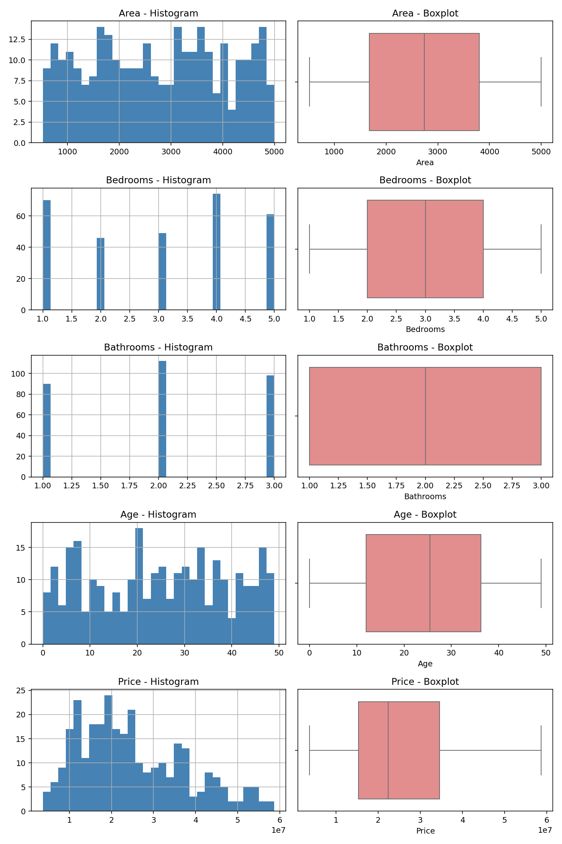
Figure 1. Histogram and boxplot for all five numeric columns.
Area, Bedrooms, Bathrooms, and Age are all approximately symmetric (|skew| < 0.15) with no flagged outliers. Price shows mild right skew (0.66) — a small number of high-value properties pull the distribution's tail rightward, typical of real-estate price data.
Bedrooms and Bathrooms are discrete count variables rather than continuous measurements, which is visible in their histograms as separated spikes rather than a smooth curve. This is expected given their limited value range and does not indicate a data quality issue.

4.1 Categorical Column Distribution
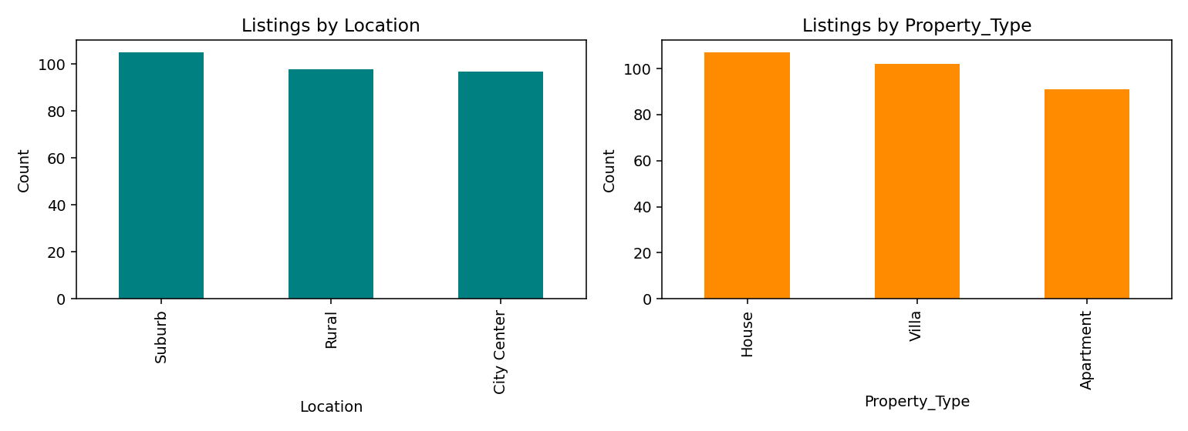
Figure 2. Listing counts by Location and Property_Type.
Both categorical columns are reasonably balanced across their categories, with no single category dominating the dataset — Location counts range from 96 to 105 listings per category, and Property_Type from 91 to 105.

5. Exploratory Data Analysis — Bivariate

5.1 Numeric vs Numeric
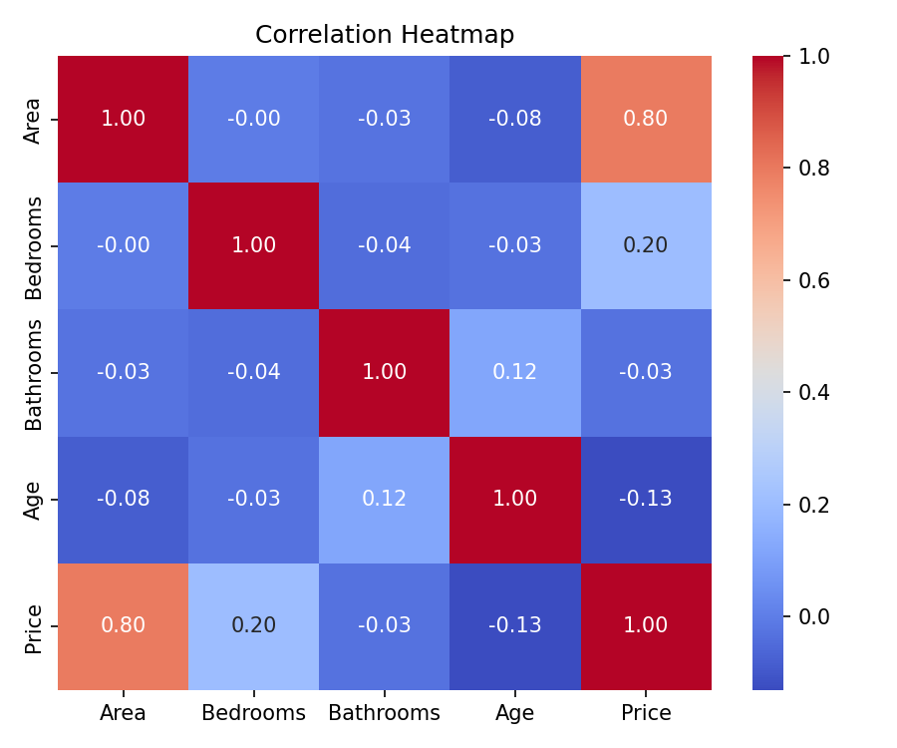
Figure 3. Correlation heatmap across numeric columns.
Area correlates strongly with Price (r = 0.80) — the clearest relationship in the dataset. Bedrooms shows a weak positive correlation with Price (r = 0.20). Bathrooms and Age show negligible correlation with Price (r = -0.03 and -0.13 respectively).
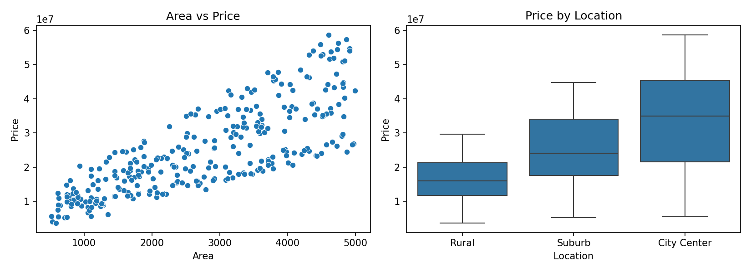
Figure 4. Area vs Price scatter plot showing a clear positive linear trend.

5.2 Numeric vs Categorical
Location | Mean Price (INR)
City Center | 3,31,49,794
Suburb | 2,51,08,071
Rural | 1,64,61,429

Property_Type | Mean Price (INR)
Apartment | 2,71,24,203
Villa | 2,49,89,853
House | 2,28,76,916

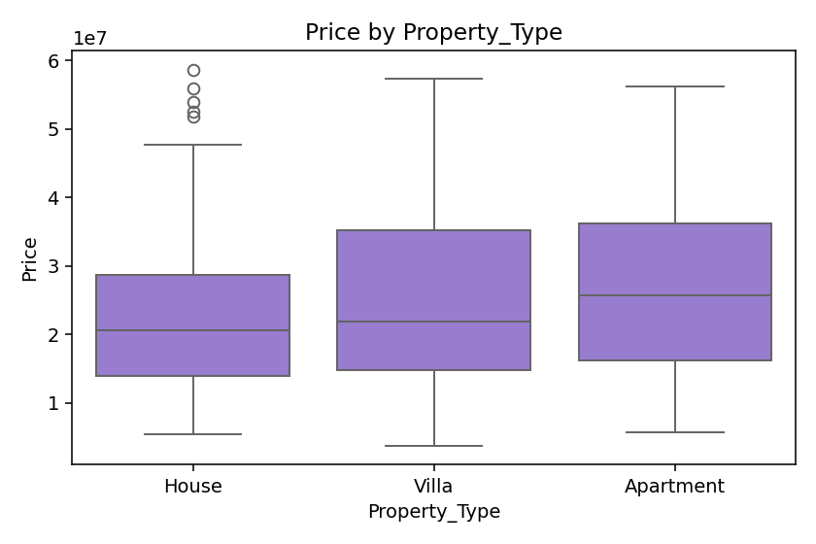
Figure 5. Price distribution by Property_Type — considerable overlap between categories.
Location shows a clear, ordered effect on mean Price (City Center > Suburb > Rural), while Property_Type differences are comparatively small and the boxplots overlap substantially — a pattern later confirmed (or refuted) formally in Section 7.

5.3 Categorical vs Categorical
A crosstab of Location × Property_Type shows listings spread evenly across combinations (28–37 per cell out of 300 total), suggesting no structural association between the two categorical variables — i.e., no location specializes in a particular property type.

6. Feature Engineering
A derived metric, Price_per_sqft (Price ÷ Area), was computed to normalize price by property size and enable fairer comparison across listings of different scale.
Metric | Value
Mean Price/sqft | ₹9,543
Std Dev | ₹3,186
Min | ₹4,556
Max | ₹21,740

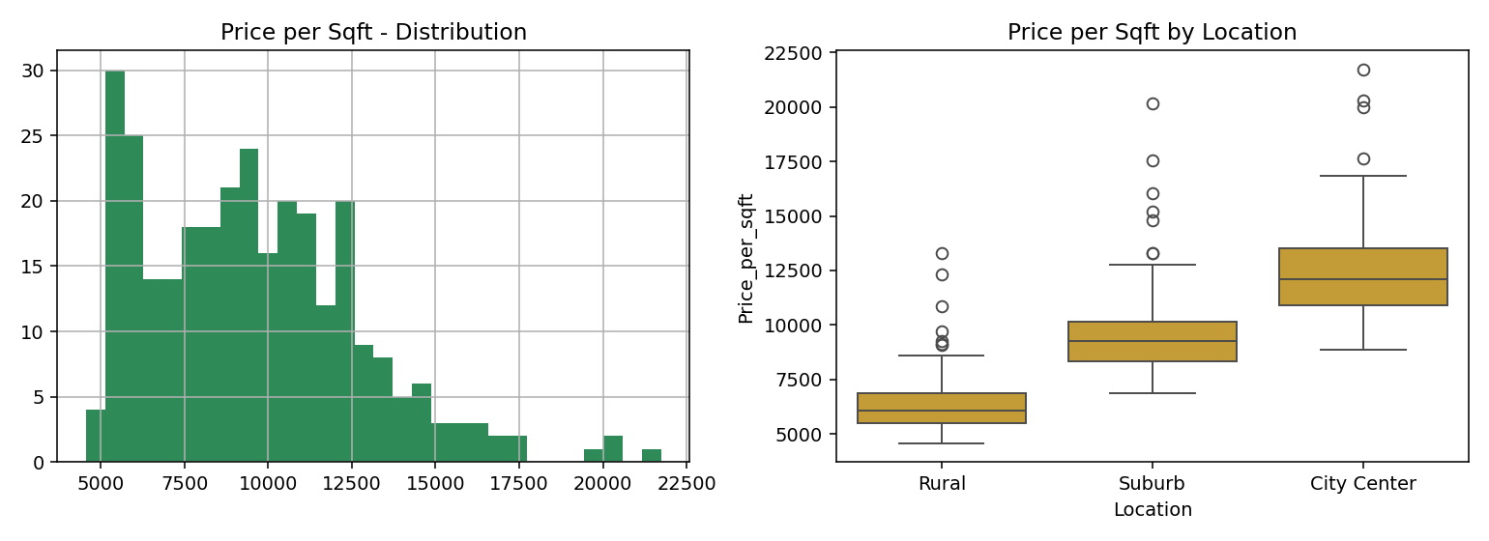
Figure 6. Price-per-sqft distribution, and by Location.
Price per square foot shows the same Location ordering as raw Price (City Center ₹12,526 vs Rural ₹6,442 per sqft) — confirming that Location's effect on Price is not simply an artifact of City Center properties being larger; City Center properties genuinely command a higher rate per square foot, not just a higher price from added size.
This derived feature would be a strong candidate input if this analysis were extended into a predictive pricing model, alongside raw Area and Location.

7. Statistical Analysis — Hypothesis Testing
The relationships suggested by EDA were formally tested at significance level α = 0.05 to confirm they reflect real effects rather than sampling noise. Four tests were run, each pairing an appropriate statistical method to the variable types involved.
Test | Question | Statistic | p-value | Conclusion
One-way ANOVA | Does Location affect Price? | F = 58.68 | < 0.001 | Significant
One-way ANOVA | Does Property_Type affect Price? | F = 2.80 | 0.062 | Not significant
Pearson correlation | Is Area–Price correlation real? | r = 0.80 | < 0.001 | Significant
Chi-square | Are Location and Property_Type associated? | χ² = 0.45 | 0.978 | Not significant

Interpretation: Location's effect on Price is highly significant (p < 0.001) — the differences observed in Section 5.2 are extremely unlikely to be due to chance. The Area–Price correlation is similarly robust (p < 0.001, effectively certain given the sample size).
Property_Type's apparent mild effect on Price, visible in the boxplot comparison in Figure 5, does not reach statistical significance (p = 0.062) — just above the 0.05 threshold. This is a useful reminder that visual patterns require formal testing before being treated as conclusive; a plot can suggest a relationship that, on rigorous testing, is more likely explained by sampling variation.
Location and Property_Type were confirmed statistically independent (p = 0.978), consistent with the even crosstab distribution observed in Section 5.3.

8. Key Findings
- Area is the strongest driver of Price, both by correlation strength (r = 0.80) and statistical significance (p < 0.001).
- Location has a significant, ordered effect on Price: City Center > Suburb > Rural (ANOVA p < 0.001), confirmed at the per-square-foot level as well, not merely a size artifact.
- Property_Type does not have a statistically significant effect on Price (p = 0.062).
- Bedrooms, Bathrooms, and Age show weak or negligible individual relationships with Price.
- Location and Property_Type are statistically independent of each other (p = 0.978).

9. Limitations
- Dataset size is moderate (n = 300); findings may not generalize beyond this sample's distribution.
- The dataset displayed no missing values, duplicates, or outliers — cleaner than most real-world data — so the cleaning stage of this report demonstrates methodology more than it reflects a difficult cleaning problem.
- Statistical significance indicates association, not causation — Location's effect on Price may be mediated by unmeasured factors such as local demand or infrastructure.
- Only linear correlation (Pearson) was tested for numeric relationships; non-linear relationships between features and Price were not explored.
- The Property_Type result (p = 0.062) is borderline; a larger sample could shift this conclusion in either direction and would be worth revisiting.

10. Recommendations & Next Steps
- Build a regression model predicting Price from Area, Location, and Price_per_sqft to quantify how much combined variance these features explain (R²).
- Deprioritize Property_Type, Bedrooms, Bathrooms, and Age as pricing factors given their weak/non-significant individual effects.
- Collect a larger sample to re-test the borderline Property_Type result with greater statistical power.
- Investigate potential interaction effects, e.g. whether the Area–Price relationship differs by Location.

11. Conclusion
This analysis establishes Area and Location as the primary, statistically validated drivers of property Price in this dataset, while Property_Type, Bedrooms, Bathrooms, and Age contribute little independent signal. The derived Price_per_sqft metric confirmed that Location's price effect reflects genuine value differences rather than a size artifact. Together, the cleaned dataset, documented EDA, and validated hypothesis tests provide a solid, reproducible foundation for a next-stage predictive pricing model.

Appendix A — Glossary of Statistical Terms
- IQR (Interquartile Range): the spread of the middle 50% of a dataset (Q3 − Q1); used to flag statistical outliers beyond 1.5×IQR from the quartiles.
- p-value: the probability of observing data this extreme if the null hypothesis were true. Smaller values indicate stronger evidence against the null hypothesis.
- Null hypothesis (H0): the default assumption of "no effect" that a statistical test tries to rule out.
- ANOVA (Analysis of Variance): a test comparing means across three or more groups to determine if at least one differs significantly.
- Pearson correlation (r): a measure from -1 to +1 of the strength and direction of a linear relationship between two numeric variables.
- Chi-square test: a test of association between two categorical variables, comparing observed vs expected frequencies.
- Skewness: a measure of distribution asymmetry; values near 0 indicate a symmetric distribution, larger magnitudes indicate a longer tail on one side.

Appendix B — Source Files
- 1_data_cleaning.ipynb — data profiling, quality checks, export to clean_data.csv
- 2_eda.ipynb — univariate and bivariate exploratory analysis
- 3_analysis.ipynb — hypothesis testing (ANOVA, Pearson correlation, Chi-square)
- clean_data.csv — validated dataset used throughout this report

